Wi-Fi access point with Ubuntu on a rPi

My setup
I’m using a rPi4 for this project which is connected with the ethernet port to the internet. The on-board Wi-Fi is used for the access point. For the OS the Ubuntu Server version is used.

SW for creation bootable SD card
Download and install the “Raspberry Pi Imager” on a Windows PC. You can download it here:
https://www.raspberrypi.com/software/
With SHIFT +CTRL+L you can change the language.

Creating bootable Ubuntu SD card

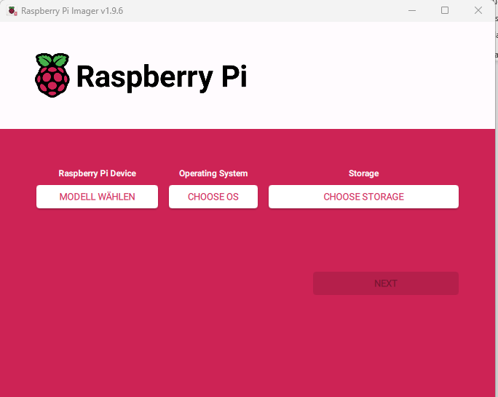

Select the rPi device:
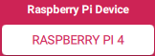

Select the OS:
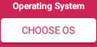



Select the storage:

Click on next:

Select “EDIT SETTINGS”
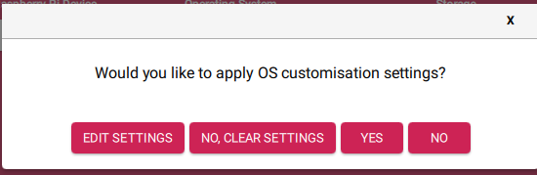

General tab:
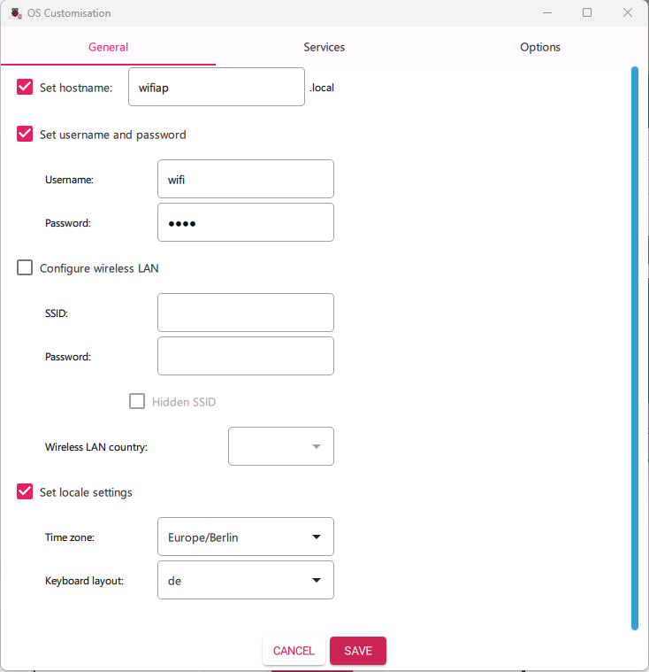
Services tab:
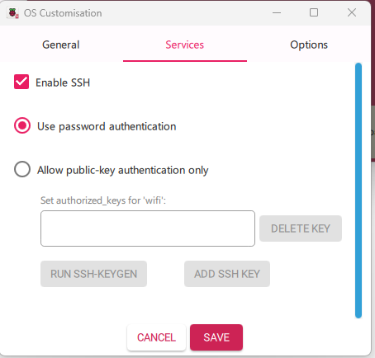
Options tab:
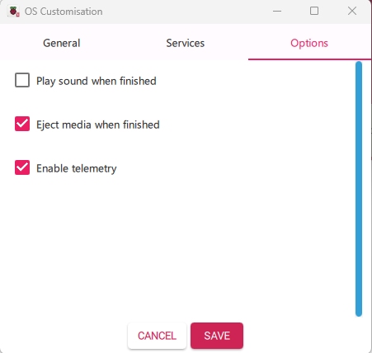
Click on:

Click on Yes:
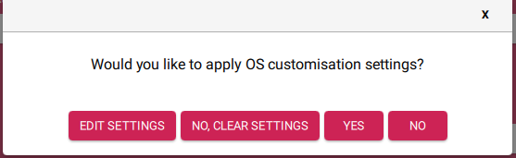

Click on YES:
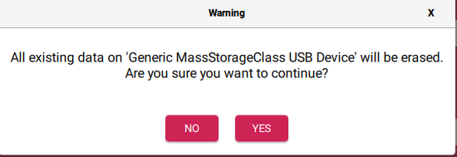
Wait till the OS is written and verified:
Now you can use the SSD in the rPi:
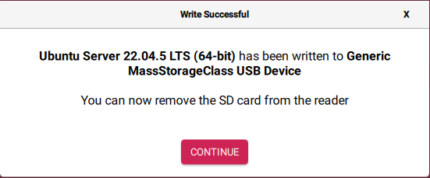

Boot your rPi from the SD card and configure it
At the first boot the rPi will perform a cloud-inti. The best will be to have a monitor connected to the rPi. This cloud-init will take time.
It’s finished and you had connected a monitor you get the following message:
“Reached target cloud-init.target – Cloud-init target.”
You can also get the status in the console:
cloud-init status

Configure:
The best way is to connect with SSH via ethernet to the rPi with the user/password wifi/wifi. Then you can copy the commands following.
In the home directory (cd ~) execute the following command.

cd ~
git clone https://github.com/InTheCar/rPi-WLAN-access-point

change to the GitHub clone directory:
cd rPi-WLAN-access-point

make the scrips executable:
chmod 755 *.sh

At first install “linux-modules-extra-raspi”
./1_install_linux-modules-extra-raspi.sh
Press ENTER:
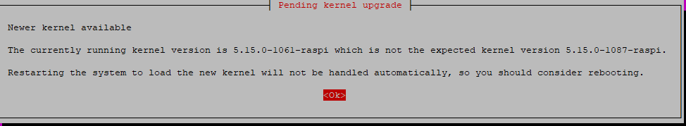
Due to new kernel Reboot the rPi automatically by the script.

sudo nano /etc/needrestart/needrestart.conf
This line:
#$nrconf{restart} = 'i';
Change to:
$nrconf{restart} = 'a';

The next step took 17 minutes.
Login again and change to the directory of the repository:
cd rPi-WLAN-access-point/

./2_update.sh

Login again and change to the directory of the repository:
cd rPi-WLAN-access-point/

install the packages which are needed:
./3_installAPPs.sh

Installation is finished. Now the configuration will be started.
Login again and change to the directory of the repository:
cd rPi-WLAN-access-point/

./4_configuration.sh
May be you have to wait (max 5 minutes) till the rPi is reachable again.

Start on Boot

sudo wpa_passphrase wifiap password

sudo systemctl unmask hostapd
sudo systemctl enable hostapd
sudo systemctl start hostapd

sudo apt-get purge --auto-remove packagename

